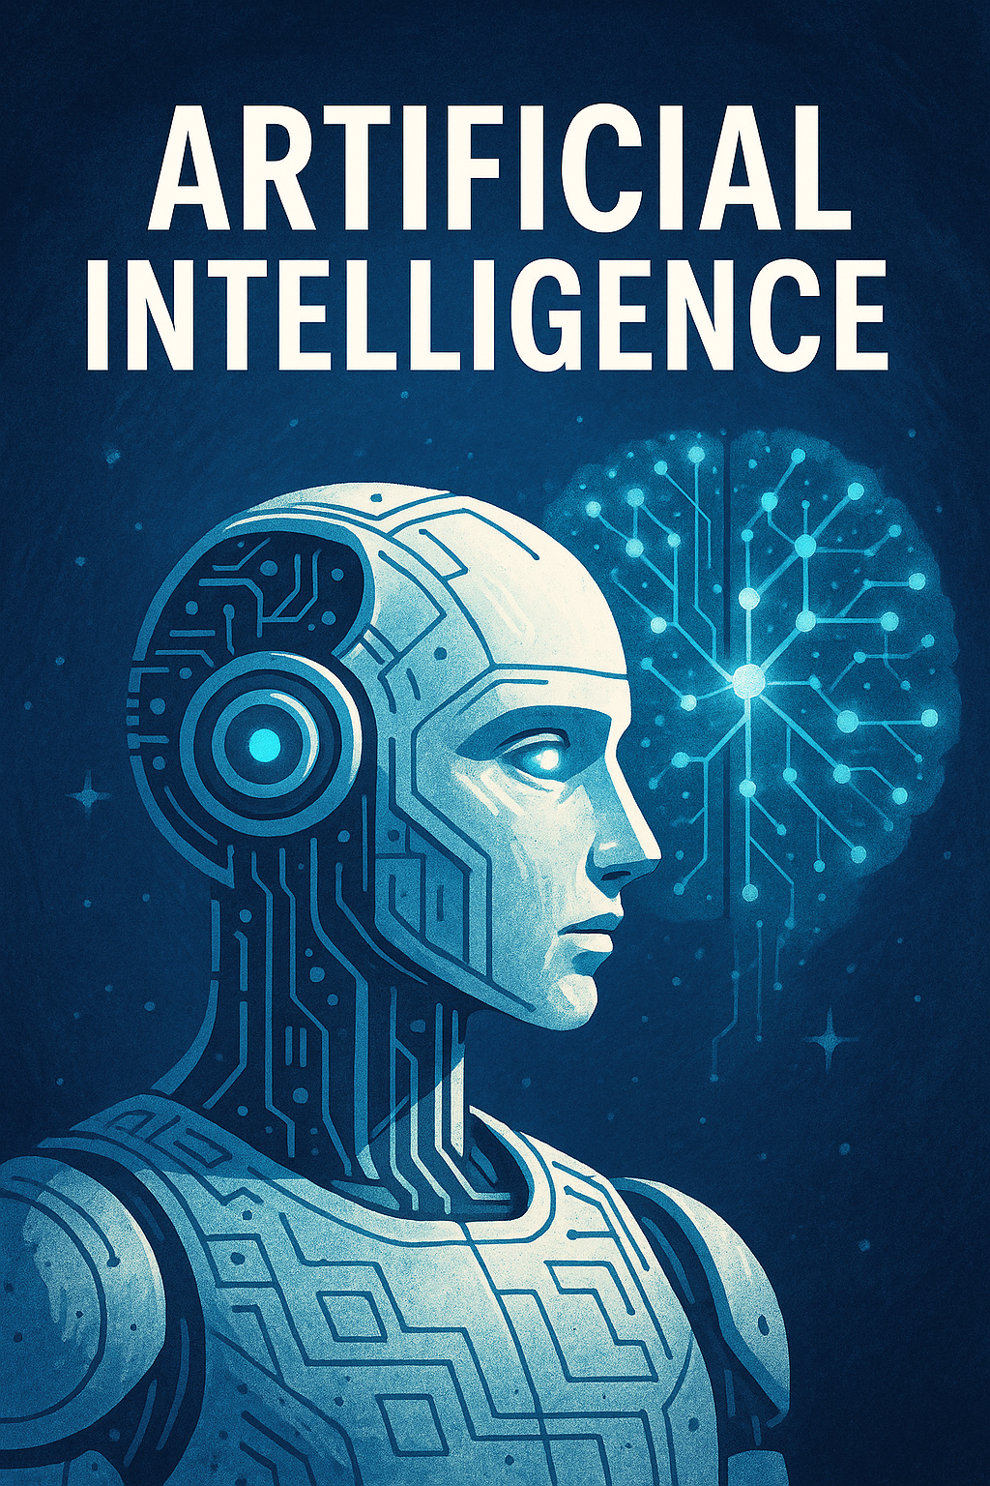
Artificial Intelligence Curriculum for College Graduates / Final Year Students
[Document subtitle]
Gnaniyar Zubair |  | A2000 India

Program Structure:

Theory: 100 Hours

Practical: 200 Hours (includes 40 hours of training at the Technology Hub; the remaining 160 hours delivered through the Outreach Center)

Module | Duration | Theory Hours | Practical Hours | Station Used
Module 1: Fundamentals of AI & Engineering Concepts | 20 Hours | 10 | 10 | Intro to Engineering Station
Module 2: Artificial Intelligence in Augmented & Virtual Reality | 35 Hours | 10 | 25 | Intro to AR/VR Station
Module 3: Python Programming & AI Logic Development | 40 Hours | 14 | 26 | Intro to Coding Station

Module 4: Humanoid Robotics & AI Motion Planning | 35 Hours | 12 | 23 | Humanoid Robotics Station
  Module 5: AI for Smart & Autonomous Transportation | 30 Hours | 10 | 20 | Smart Transportation Station
Module 6: AI for Industry 4.0 and Smart Manufacturing | 35 Hours | 12 | 23 | Industry 4.0 Station
Module 7: Internet of Things (IoT) with AI  Integration | 30 Hours | 10 | 20 | IoT Station
Module 8: AI & Spatial Computing (Projected Reality) | 25 Hours | 8 | 17 | Projected Reality Station
Module 9: AI for Esports, Gaming & Real-Time Graphics | 30 Hours | 8 | 22 | EsportsLab Station
Module 10: AI Ethics, Explainability, and Prompt Engineering | 20 Hours | 10 | 10 | Multi-Station / Online Tools
 | 20 Hours | 6 | 14

Capstone Project: Multistation AI Integration & Deployment |  |  |  | Multi-Station Integration
Total: | 300  Hours | 100  Hours | 200  Hours


Detailed Module Plan

Module 1: Fundamentals of AI & Engineering Concepts

Theory Topics:
- AI history and evolution, symbolic vs. neural AI
- Robotics basics: sensors, actuators, and control systems
- Engineering principles for problem-solving using AI

Practical Tasks:
- Build simple robots with STEM kits
- Program basic motion and obstacle avoidance

Module 2: AI and Augmented/Virtual Reality
Theory Topics:
- Fundamentals of AR/VR and mixed reality
- Role of computer vision in AR/VR
- Enhancing immersion using AI-generated environments

Practical Tasks:
- Build AR/VR scenes using Blockly or Unity-based tools
- Train simple AI to interact within virtual environments

Module 3: Python Programming & AI Logic Development
Theory Topics:
- Python basics: variables, loops, data types
- AI logic: conditionals, states, and search algorithms
- Supervised learning vs. unsupervised learning

Practical Tasks:
- Program logic-based games with block coding & Python
- Implement mini-projects using scikit-learn or TensorFlow Lite

Module 4: Humanoid Robotics & AI Motion Planning

Theory Topics:
- Vision-based navigation & face detection
- NLP for interaction with humanoid robots
- Motion planning algorithms (A*, Dijkstra)

Practical Tasks:
- Program NAO/Alpha Mini for speech interaction and movements
- Facial expression mimicry using AI models

Module 5: AI for Smart & Autonomous Transportation
Theory Topics:
- Self-driving car architecture
- AI for route optimization & collision prediction
- Drone-based data analysis

Practical Tasks:
- Program Zumi car to navigate real-world layouts
- Simulate traffic signals and autonomous drone delivery

Module 6: AI for Industry 4.0 & Manufacturing
Theory Topics:
- Cyber-physical systems and predictive maintenance
- AI for quality control & defect detection
- Digital twins and simulation with AI

Practical Tasks:
- Use Dobot for pick-and-place operations
- Train AI models for object classification on the line

Module 7: AI in IoT
Theory Topics:
- AI + IoT architecture and data pipelines
- Edge AI, TinyML, and sensor integration
- Security and encryption in smart devices

Practical Tasks:
- Build smart home devices with AI triggers
- Deploy ML models on microcontrollers (ESP32/Raspberry Pi)


Module 8: AI & Projected Reality (Spatial Computing)
Theory Topics:
- Projection mapping and AI interactions
- Gesture and speech control in projected interfaces
- AI in education and digital twins

Practical Tasks:
- Create interactive learning environments
- Control AI avatars using real-time projections

Module 9: AI in Esports and Game Development
Theory Topics:
- NPC behavior modeling and reinforcement learning
- Game AI frameworks and emotion-based design
- Real-time analytics for Esports performance

Practical Tasks:
- Build multiplayer AI agents
- Analyze game performance using tracking data

Module 10: AI Ethics, Explainability, and Prompt Engineering
Theory Topics:

- Ethical AI, bias detection, and fairness
- Explainable AI (XAI) models and tools
- Introduction to Prompt Engineering for GenAI tools

Practical Tasks:
- Use LIME/SHAP for model explanation
- Build prompts for ChatGPT/Bard to automate academic/research tasks

Capstone Project
Objective: Cross-functional project integrating at least two stations (e.g., IoT + Robotics or AR/VR + Game Dev)
Deliverables: Final report, deployment-ready prototype, demo video, and pitch deck

